|  |  |
| --- | --- |
| **Project Case** |  |
| COMP6232001 | COMP6800 | COMP6800001  Human and Computer Interaction |
| **Computer Science** | **E232-COMP6800-HI12-00** |
| ***Valid on*** *Even Semester Year 2022/2023* | **Revision 00** |

1. Kelompok tidak diperkenankan untuk:

*Members of the group are prohibited from:*

* + - Melihat sebagian atau seluruh jawaban kelompok lain,

*Seeing a part or the whole answer from other groups,*

* + - Menyadur sebagian atau seluruh jawaban dari buku, catatan, video, dan jenis referensi lainnya,

*Retell a part or the whole answer from books, notes, videos, and other references,*

* + - Menyadur sebagian atau seluruh jawaban dari internet,

*Retell a part or the whole answer from the internet,*

* + - Mengumpulkan jawaban yang tidak sesuai dengan tema soal,

*Submitting an answer with a different theme from the given case,*

* + - Melakukan tindakan yang menyebabkan jawaban dicontek oleh orang lain atau kelompok lain, baik disengaja maupun tidak disengaja,

*Doing action that could result the answer being copied by someone or other groups, intentionally or unintentionally,*

* + - Melakukan tindakan kecurangan lainnya.

*Committing other dishonest actions.*

1. Jika kelompok terbukti melakukan tindakan seperti yang dicantumkan pada butir ke-1, maka nilai mahasiswa dan/atau kelompok yang melakukan kecurangan, baik menyontek atau dicontek, akan dinolkan sesuai dengan peraturan yang berlaku.

*If it has been proven that a group has committed dishonest actions outlined in point 1 above, the whole groups related to the incident, regardless of which one copies or has their answer copied, will be issued a score of zero according to the regulation.*

1. Jawaban yang dapat diterima dan dinilai adalah jawaban yang dikumpulkan sebelum batas waktu yang telah ditentukan.

*The answer must be submitted before the designated deadline to be accepted and graded,*

1. Jawaban akan dinilai berdasarkan teknik atau metode yang diajarkan pada kelas praktikum dengan menggunakan software yang sudah ditentukan.

*The scoring will be based on the materials taught during the practicum classes using the designated software. Using different software than requested may result in your answer not being graded.*

1. Jika Anda tidak membaca peraturan ini, maka Anda dianggap sudah membaca dan menyetujuinya.

*By taking this exam, you agree to these regulations, regardless of whether you have read it or not.*

1. Persentase penilaian untuk matakuliah ini adalah sebagai berikut:

*The score will be distributed as follows:*

|  |  |  |
| --- | --- | --- |
| **Tugas Mandiri**  *Assignment* | **Proyek**  *Project* | **UAP**  *Final Exam* |
| - | 100% | - |

1. Perangkat lunak yang digunakan pada matakuliah ini adalah sebagai berikut:

*This course uses the following software:*

|  |
| --- |
| **Software**  *Software* |
| Chrome / Firefox / Microsoft Edge  Figma  Visual Studio Code |

1. Ekstensi file yang harus dikumpulkan untuk matakuliah ini adalah sebagai berikut:

*Your answers must be in the following file extensions:*

|  |  |  |
| --- | --- | --- |
| **Tugas Mandiri**  *Assignment* | **Proyek**  *Project* | **UAP**  *Final Exam* |
| - | FIG, HTML, CSS, JS, Image Files (JPG / PNG) | - |

1. File yang harus dikumpulkan adalah keseluruhan jawaban beserta dengan aset yang digunakan (gambar, audio, video, dll) dan dokumentasi proyek yang berisikan link referensi aset dan penjelasan mengenai aplikasi yang dibuat (terlampir bersama dengan soal).

*Include other files that can support your project, such as: all files in your project, other files (image, audio, video, etc.) used in your project, *.doc file (documentation of your project) that contains all pages in your project, reference links of additional files (image, audio, video, etc.) used in your project, the description about how to use your application, etc.*

## Soal

*Case*

**HI-Toyz**

**HI-Toyz** is a toy store that has been around since 2019. **HI-Toyz** is a toy store that sells plastic model kits and figure statues. **HI-toyz** has a special place in the hearts of local collectors, **HI-Toyz** provides a selection of toys from various brands and has also become an activity center for toy collectors. **HI-Toyz** has also become an official reseller for big brands such as tamiya, bandai, mattel toys, mini-GT and others.

**HI-Toyz** is currently planning to **create a website** to sell products online, so they can reach more buyer from all around the world. First, **HI-Toyz** needs to **create a website prototype** and **company website** that represents the **HI-Toyz** image. With this image, **HI-Toyz** hopes to improve service to its customers. **HI-Toyz** entrusts you as a web designer to **design their** **website prototype** and **create a company website**.

The **requirements** from **HI-Toyz** Shop are described below:

* + - 1. **HI-Toyz** wants you to design the **website prototype** of all **five pages** before making the HTML files. The website prototype will be created using **Figma**. Ensure the website prototype that you created is the **exact same** with the website that you will make later. Each pagewill contain **header**, **navigation**, **content,** and **footer** as its structure. Consider the **color**, **layout**, and **consistency** when designing the prototype.
      2. **HI-Toyz** wants you to build the **website attractive**, **appealing**, **fully functional**, and make sure the website is **responsive**. The website should be accessible using a mobile phone in a perfect way. To achieve that, use **5 kinds of CSS property** and **JavaScript**. Use **meta** **viewport** **tag** and **media** **screen** **rule** that will be applied if the screen is **below** **768px** screen width.
      3. The website consists of **five main pages**. They are **Home Page**, **Products Page**, **Gallery Page**, **Event Page**, and **Register Page**. Below are the **requirements** for each page:
* **Home Page (BESOK)**

This page shows **HI-Toyz background** **history** and **tagline** as a toy store that has been established since 2019 and has become part of the local collectors. This page also **shows items** that are in great demand by collectors.

* **Products Page**

This page **shows list of toys** that **HI-Toyz** sells. Make sure to provide **name, price, description,** and **image** of the product so customer can get better insight about the product and decide which product to buy.

* **Gallery Page**

This page **contains photos of the HI-Toyz offline store**, besides that this page also contains **photos of customers** who have purchased toys directly, the purpose of this page is to provide the excitement of shopping at **HI-Toyz** offline store.

* **Event Page (BESOK)**

This page **shows the activities and promos** currently at **HI-Toyz** to attract customer attention. Be sure to provide an **image**, **promo** or **activity title** and **a short description**. Make sure that the information is **relevant**.

* **Register Us Page (BESOK)**

This page provides a **member registration** **form** for the customer. Customer needs to submit some personal information, such as **name, password, email, date of birth,** and **agreement to regulations**. You are asked to create **5 kinds of form components** and **5 kinds of validation**. For validation, you must create it using **JavaScript** and **don’t use regular expression**.

**Guidelines:**

* + - * 1. Design your website by observing the principles of **human and computer interaction**. Set up your site as **creative** as possible but still strive for **consistency**.
        2. The **website prototype** must be designed using **Figma** and make suretocreate some **features**, such as color and text style, effect, component, variant or interactive component, and navigation.
        3. Consider the **color**, **font**, **size**, and **layout** that you use to design the prototype and website.
        4. All pages mentioned in the requirement should be created **based on your template design**.
        5. Use only **external** **CSS**. Internal or inline CSS will not be marked.
        6. Use **CSS box positioning** to design your web structure**,** do not use table for the layout.
        7. Consider the **language** you use, including spelling and grammar, feel free to choose either Bahasa or English, but you cannot have both at the same time.
        8. Make your website **responsive** so it can deliver in any size, particularly for **desktops**, **tablets,** and **mobile devices**.
        9. Organize your files with subdirectories.
        10. Include references (link from a website, book, etc.) that you use in creating the website.

**If you do not understand, please ask your assistant!**

**Dokumentasi Pembuatan Website**

1. **Dokumentasi Website (Penjelasan Deskripsi Website)**
   * + - 1. **Navbar (Navigation Bar)**

Navigation Bar dibuat dengan position sticky sehingga meskipun websitenya scrolling namun tetap terlihat menempel. Berisi menu Home, Products, Gallery, Events, dan Register Us yang ketika di klik akan mendirect ke page lainnya. Menu yang sedang dikunjungi ditambahkan status active supaya jadi penanda bahwa user sedang berada dalam page tersebut.



* + - * 1. **Home Page**
* **Landing Page**

Landing page merupakan halaman yang pertama kali dilihat oleh user saat masuk ke website, berisi nama toko HI-Toyz serta tagline nya yaitu “World of Toys”. Dibawah deskripsi tersebut terdapat button “learn more” yang mendirect ke section di bawahnya yaitu “Our History”.

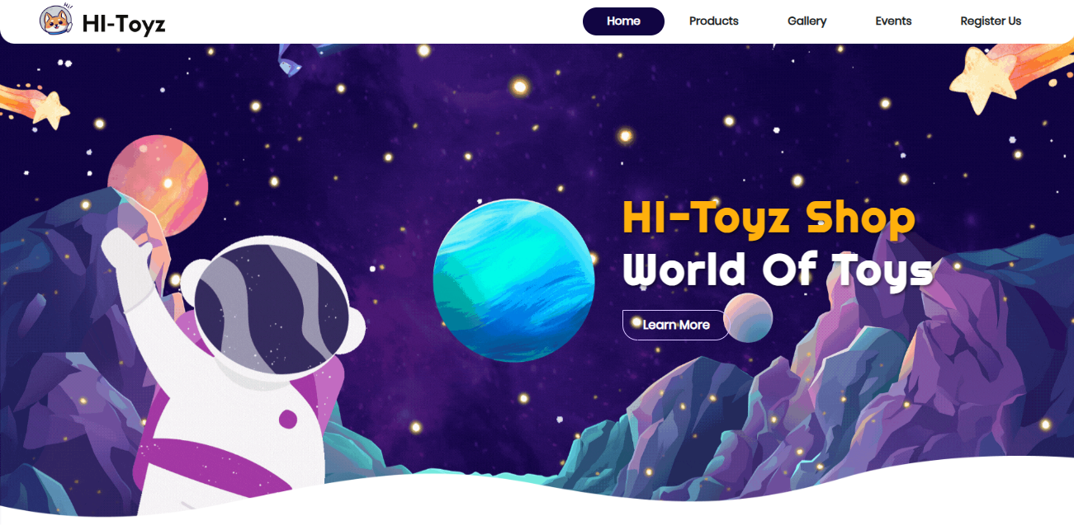

* **Our History**

Our History merupakan halaman dalam menu Home yang berisi sejarah terbentuknya toko HI-Toyz. Terlampir juga sketsa gambar toko yang menjadi representatif gambaran toko HI-Toyz.

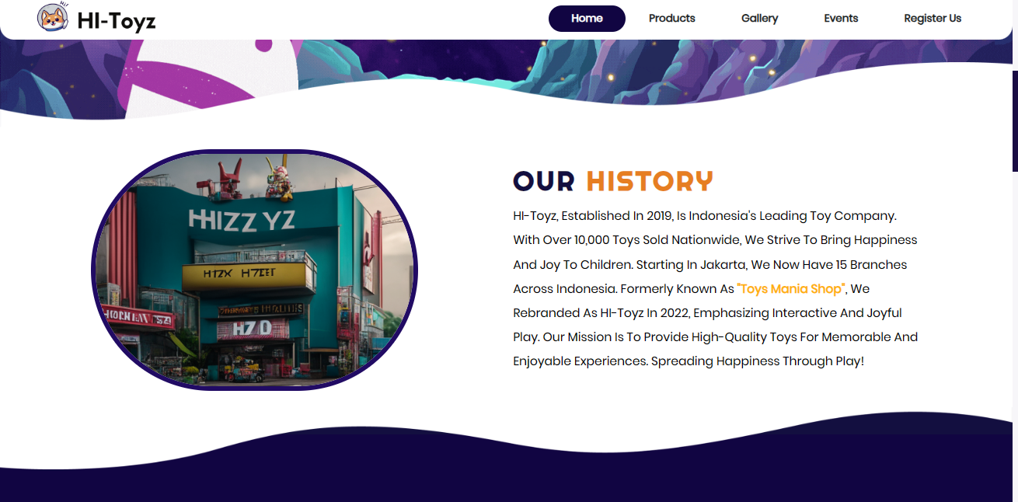

* **Our Partners**

Our partners menampilkan list top-4 partner yang bekerja sama dengan HI-Toyz dalam hal reseller yaitu Tamiya, Bandai, Mattel Toys, dan Mini GT.

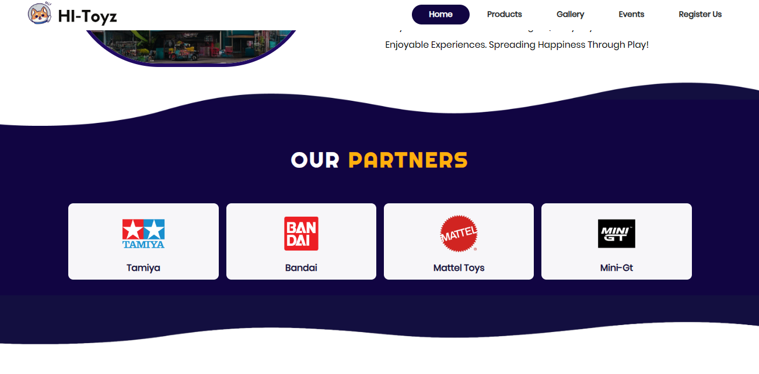

* **Popular Products**

Popular Products menampilkan 9 list produk yang diminati oleh pelanggan (produk dengan tingkat pembelian terbanyak), terlampir dokumentasi foto produk, deskripsi produk, serta button “Purchase Now” yang dapat mendirect ke menu Products.

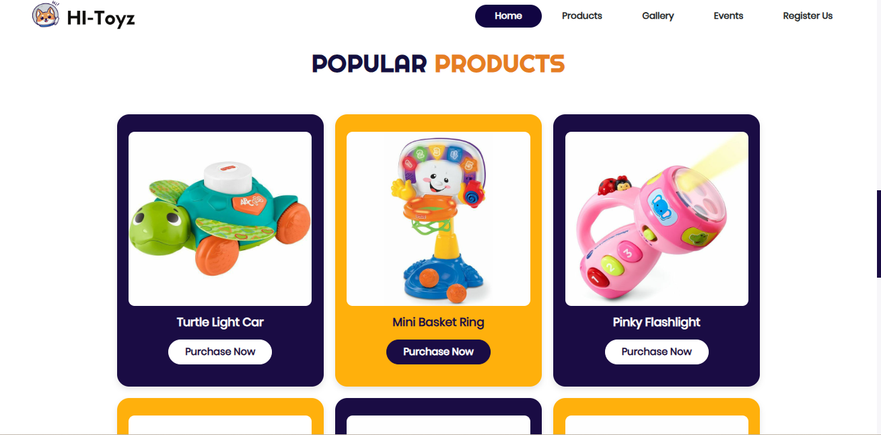

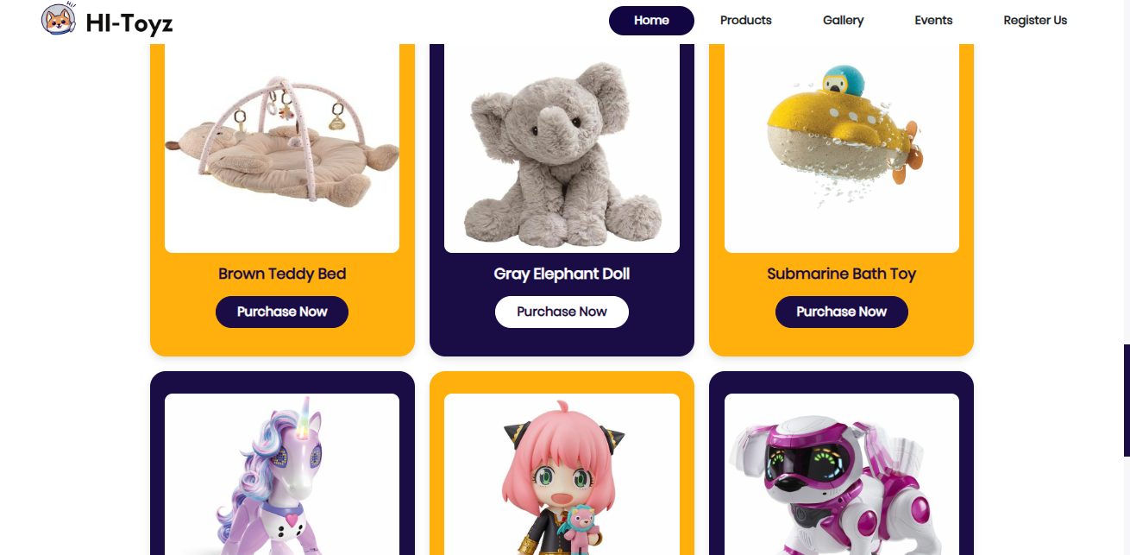

1. **Products Page**

* **Category of Toys**

Section ini berisikan 3 kategori mainan yang dijual di HI-Toyz yaitu Doll, Action Figure, dan Lego. Ketika setiap button di klik maka akan mendirect ke masing-masing section terkait.

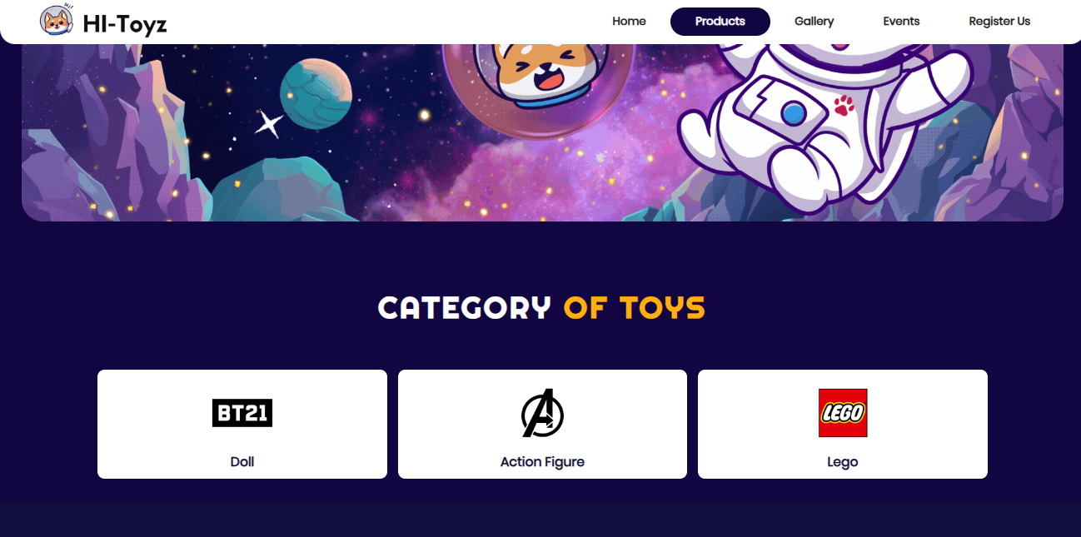

* **Doll Category**

Kategori ini berisi list boneka yang dijual oleh HI-Toyz, terdapat foto boneka, nama boneka, harga, deskripsi boneka, dan button “Purchase Now”.

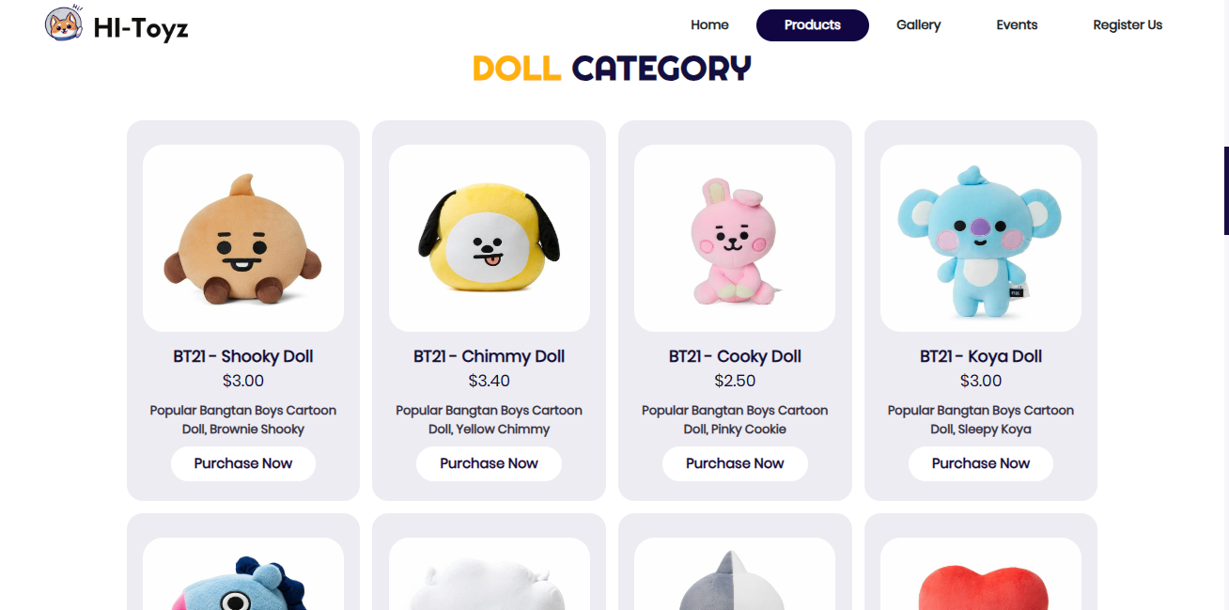

* **Action Figure Category.**

Kategori ini berisi list Action Figure yang dijual oleh HI-Toyz, terdapat foto action figure, nama action figure, harga, deskripsi action figure, dan button “Purchase Now”.

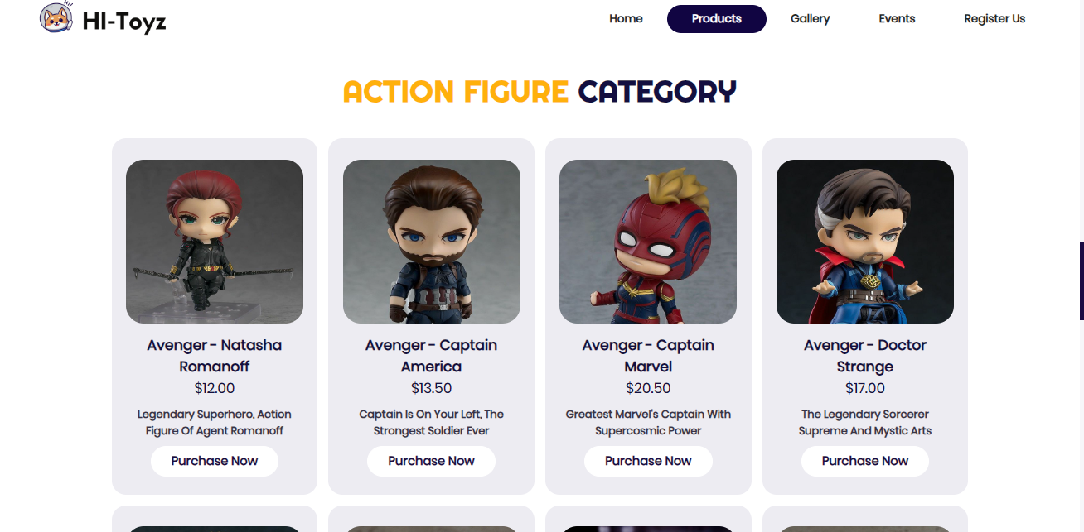

* **Lego Category**

Kategori ini berisi list lego yang dijual oleh HI-Toyz, terdapat foto lego, nama lego, harga, deskripsi lego, dan button “Purchase Now”.

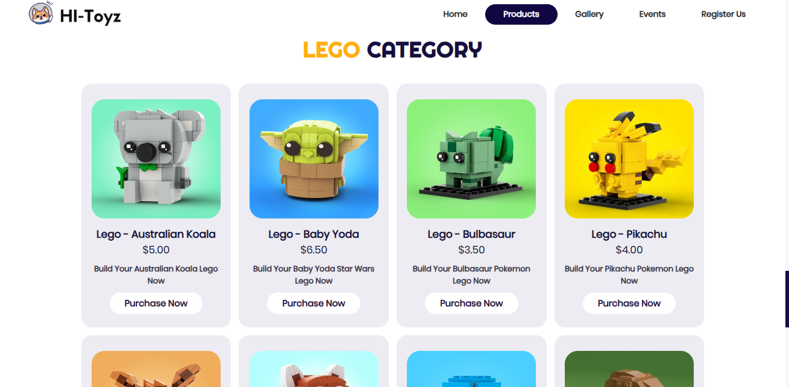

1. **Gallery Page**

* **HI-Toyz Location**

Berisi lokasi cabang toko HI-Toyz yang terletak di Jakarta (toko pusat) dan Bandung (cabang terbesar).

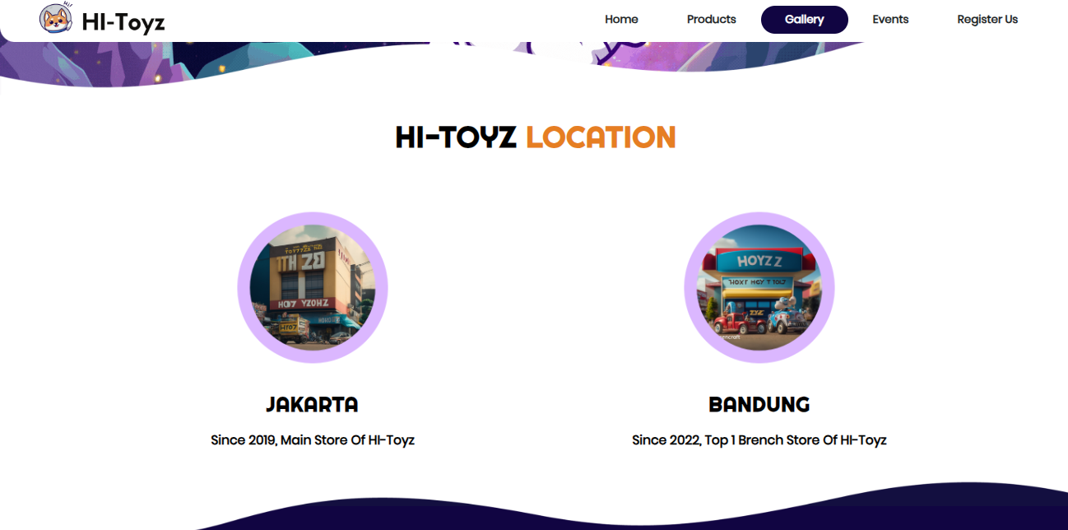

* **Happiness Memory Series**

Section ini menampilkan berbagai foto keseruan berbelanja di HI-Toyz, berisi foto, tanggal, dan deskripsi dari foto tersebut.

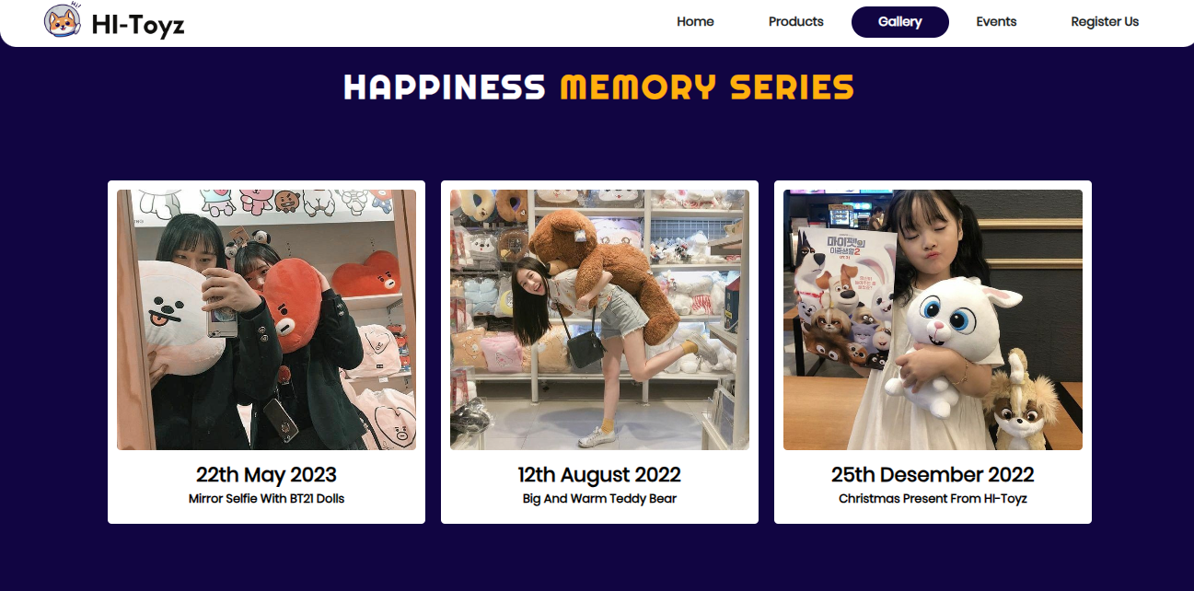

* **Customer Review**

Section ini menampilkan 3 testimoni dari pelanggan yang telah berbelanja di HI-Toyz supaya menarik minat user untuk ikut membeli mainan di HI-Toyz.

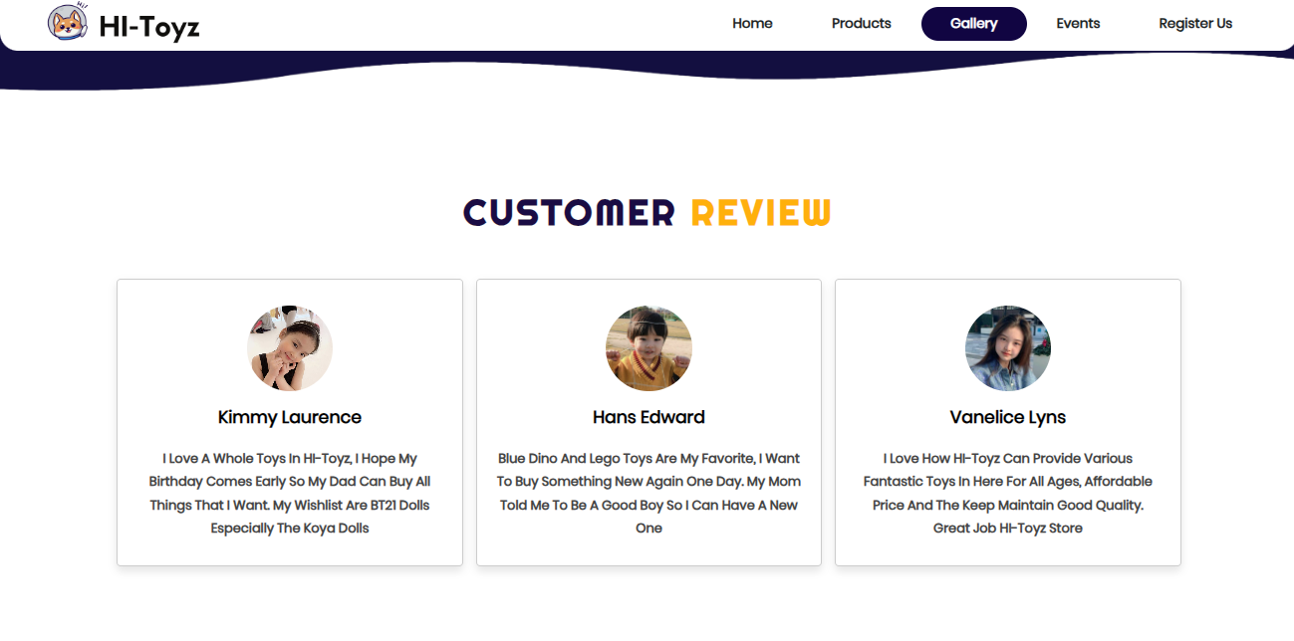

1. **Events Page**

* **Discount of The Months**

Section ini berisi tentang informasi cashback dan discount yang ada di HI-Toyz, terlampir berbagai penawaran special yang menarik minat pelanggan.

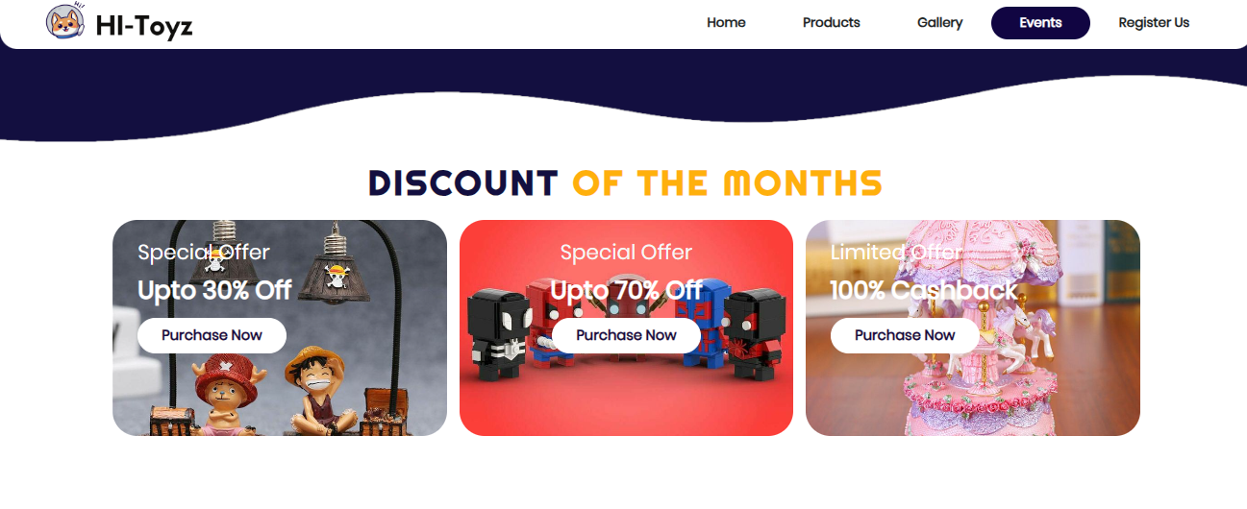

* **Our New Toys**

Section ini berisi informasi list mainan atau produk yang baru saja launching di HI-Toyz, baik di cabang Jakarta ataupun di Bandung.

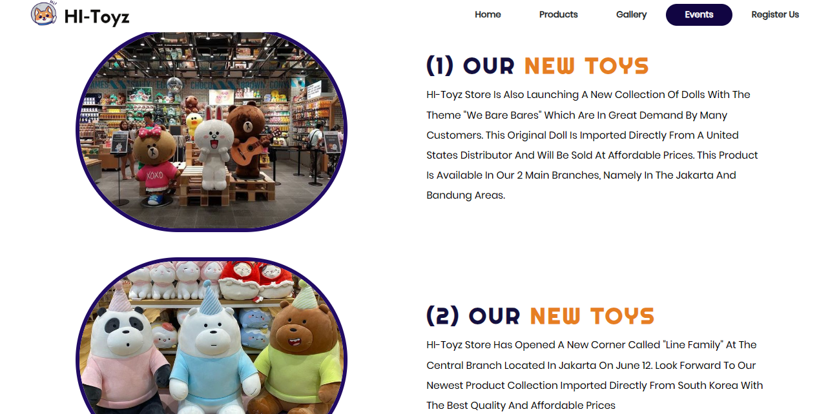

* **Our Activity**

Section ini berisi informasi kegiatan terkini atau terupdate yang terjadi di HI-Toyz, baik kegiatan launching produk, hunting produk baru, bahkan hingga keadaan HI-Toyz ketika sedang discount besar-besaran.

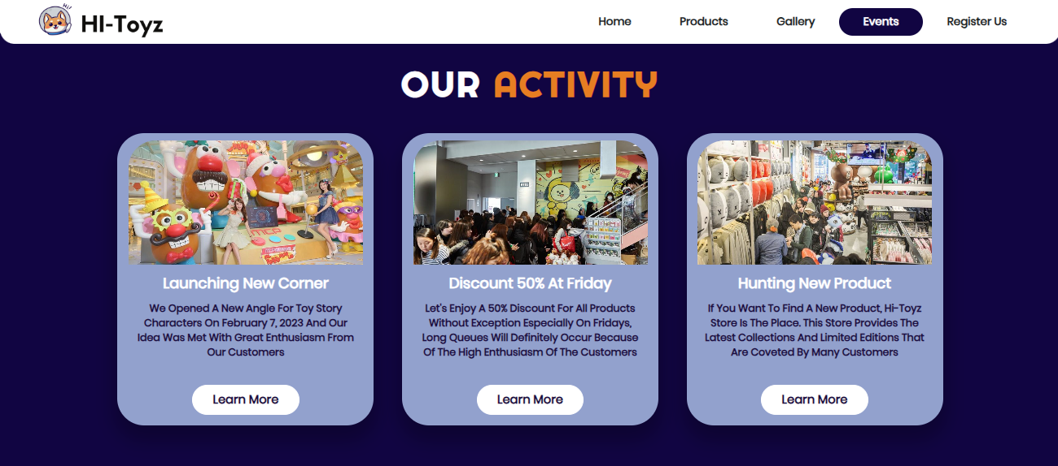

1. **Register Us Page**

* **Create New Account Page**

Section ini berisi sebuah form yang berisi nama, email, password, confirm password, date of birth, dan konfirmasi EULA untuk mendaftar menjadi member di HI-Toyz. Form ini sudah dilengkapi dengan validasi sehingga kesalahan pengisian data akan diketahui form dan muncul konfirmasi agar user bisa mengisi ulang data yang salah.

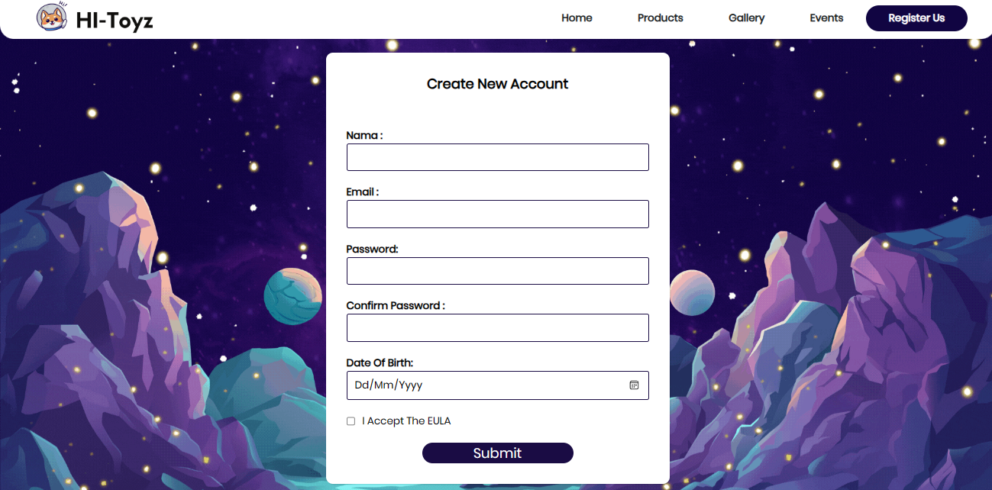

1. **Footer**

Section ini berisi misi dari HI-Toyz, nama pembuat website, serta Instagram dari pembuat website yakni Verren Angelina Saputra.



**Notes :**

* berikut saya cantumkan link youtubenya, sebagai bentuk referensi: <https://youtu.be/5JwWqjd4e9o>
* Apa yang ada di video tersebut tidak di copy paste melainkan saya pahami dan diketik ulang sebagaimana saya mengkreasikan websitenya.
* Dalam bagian file .js saya mengambil referensi dari codingan lab ko William (bagian register us).
* Link referensi assets: <https://id.pinterest.com/>
* Berbagai design bertema galaxy yang ada di page tersebut didesign sendiri oleh saya lewat aplikasi Canva, berikut adalah linknya: <https://www.canva.com/design/DAFlA3iyf4I/b4H00cBNIiFpFoGsXDNpag/edit?utm_content=DAFlA3iyf4I&utm_campaign=designshare&utm_medium=link2&utm_source=sharebutton>

**Tampilan Responsive di Handphone**

**Home Page :**

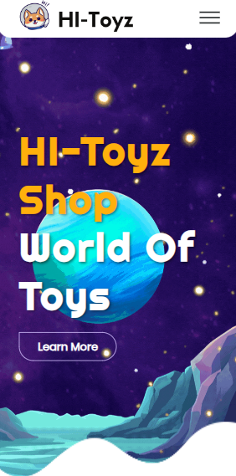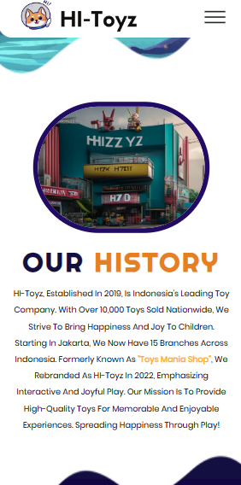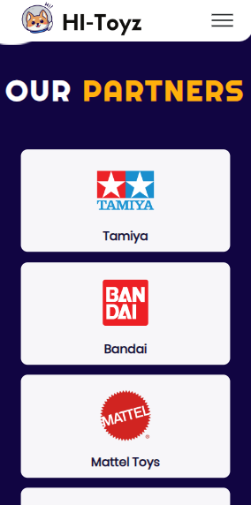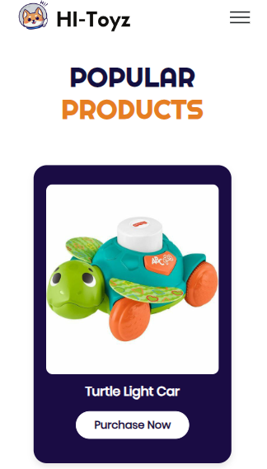

**Products Page :**

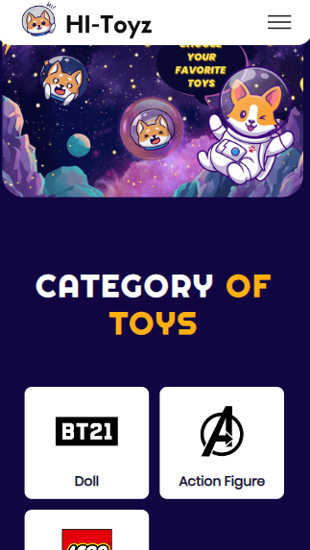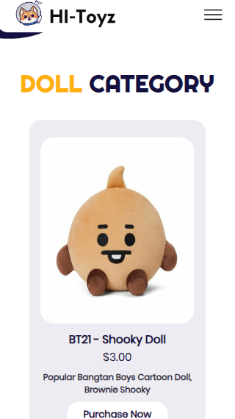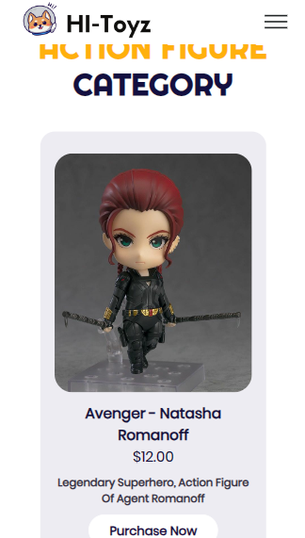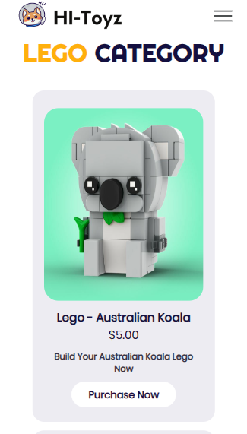

**Gallery Page :**

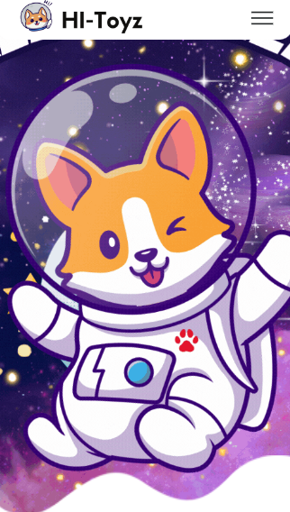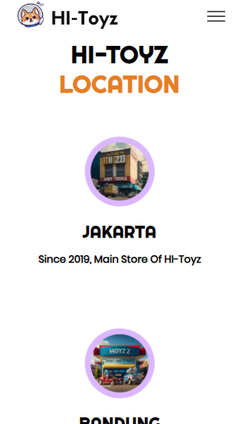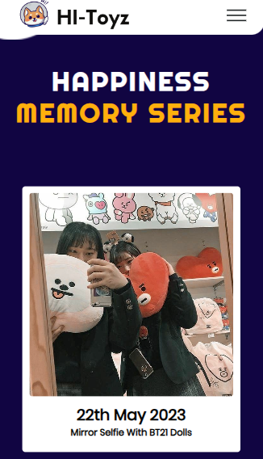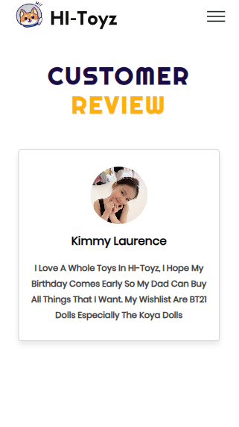

**Events Page :**

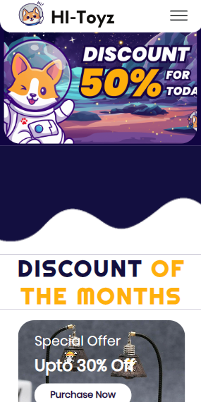 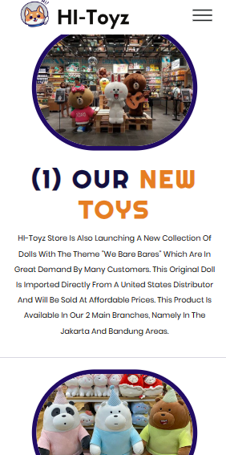 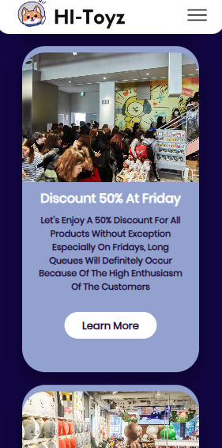 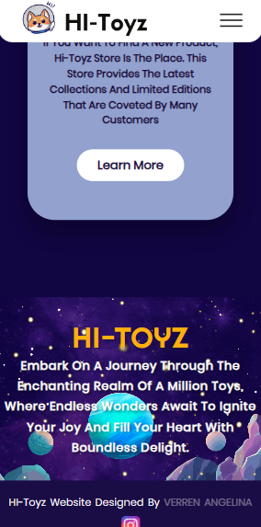

**Register Us Page :**

